Introduction to Software Engineering

Project Proposal & Plan

The student team is required to complete the Project Proposal & Plan documentation for the assigned course project, following the attached template.


Software Engineering Department
Faculty of Information and Technology
University of Science

Table of Contents
Objectives 1
1 Member Contribution Assessment 2
2 Vision 3
2.1 Preliminary Problem Statement 3
Background and Current Situation 3
Proposed System 4
Operating Environment 4
Design and Implementation Constraints 5
2.2 Product Position Statement 6
2.3 Stakeholders and Users 6
2.4 Scope and Key Features 7
3 Proposed Solution 9
3.1 Preliminary Architecture 9
3.2 Technology Stack 9
3.3 Hardware and Operating Environment 10
4 Project Plan 12
4.1 Process and Phase Gates 12
4.2 Work Breakdown Structure (WBS) 13
4.3 Estimation 14
4.4 Schedule 20
4.5 Roles and Responsibilities 24
4.6 Human Resources and Cost Estimate 25
Human resources and effort 25
Tools, hosting and other costs 25
Total cost summary 26
5 Risk Management 27
6 Tools & Collaboration Setup 29
7 AI Usage Log 30

Project Proposal & Plan

Objectives
This document focus on the following topics:
- Completing the Project Proposal & Plan document with the following sections:
  - Vision
  - Proposed Solution
  - Project Plan
  - Risk Management
  - Tools & Collaboration Setup
- Including an AI usage log for this phase
- Understanding the Project Proposal & Plan document.

Member Contribution Assessment
ID | Name | Role(s) | Contribution (%) | Evidence
24127168 | Lê Trọng Hiếu | PM | 20 | Git taskboard
24127577 | Huỳnh Mạnh Tú | Business Analysis | 20 | Git taskboard
24127183 | Trần Duy Khang | Designer | 20 | Git taskboard
24127500 | Nguyễn Đại Phúc | Developer | 20 | Git taskboard
23127134 | Phan Phú Trọng | Tester | 20 | Git taskboard

Vision

Preliminary Problem Statement

Background and Current Situation
Currently, many small and medium-sized badminton courts accept bookings through phone calls, Zalo, Facebook, or other communication channels. Some court owners record booking information in notebooks or Excel spreadsheets, while others manage information across several different platforms. As a result, booking details, court schedules, prices, and availability may be scattered across different sources rather than maintained in one centralized system.
This situation creates difficulties for both players and court staff. Players often have to contact multiple venues to ask about court availability, prices, and locations before finding a suitable time slot. This process can be time-consuming and inconvenient, especially during peak hours from 5 PM to 9 PM, when courts are in high demand. Players may also receive outdated or inconsistent information about available time slots, which can lead to confusion and frustration.
Court owners and staff also face challenges when managing bookings manually. They must frequently check and update schedules, verify availability, calculate prices based on different time slots, and communicate booking information to customers. When information is stored in multiple places, it becomes more difficult to keep records consistent and track changes accurately. These manual processes increase the risk of human error, including incorrect price calculations and double bookings, where multiple customers are assigned to the same court during overlapping time slots.
In addition, customers who make reservations but do not show up can leave courts unused and reduce potential revenue. Without an organized system for managing booking information and recording customer attendance, court owners and staff may find it difficult to monitor bookings and handle these situations consistently.
Therefore, a centralized web-based system is needed to make court availability and pricing easier for players to access and to help court owners and staff manage bookings more accurately and efficiently.

Proposed System
BadminBookingHub is a web-based system that lets players register, log in, find badminton courts, view prices and available time slots, and make or cancel bookings in one place. The system automatically calculates booking prices based on the selected time slots, including peak hours and weekends. Staff can view the daily schedule, check customers in, record no-shows, and create bookings for walk-in customers. Administrators, who represent court owners, manage user accounts and roles, court information, opening hours, prices, and booking policies.
The system must never confirm two bookings for the same court in overlapping time slots. If two users try to book the same slot at the same time, only one booking can be confirmed, and the other user must be informed that the slot is no longer available. All bookings and cancellations must follow the applicable court policies, such as weekly booking-hour limits, advance-booking limits, and cancellation deadlines.

Operating Environment
BadminBookingHub will be a responsive web application accessible through modern web browsers on desktop computers and mobile devices. Players can use their phones or computers to search for courts and make bookings, while staff will primarily use computers at the front desk to manage daily operations.
The frontend will use React, TypeScript, and Vite. The backend will use Node.js, Express, and TypeScript, with PostgreSQL as the database. Git and GitHub will support version control and team collaboration, while GitHub Actions will be used for continuous integration.
Docker will support local deployment, which is sufficient for the course requirements. If time and resources permit, the team may also deploy the application to a cloud environment so that users can access it over the Internet.

Design and Implementation Constraints
The project will be developed by a five-member student team within the course schedule. The team will follow the Waterfall development process and use the V-model approach for test planning.
The team will prioritize the seven Must-have features defined in PA0. Optional features will only be considered if sufficient time and resources remain. The detailed implementation choices will be confirmed based on the team's skills, project requirements, and available time.
The system must use TypeScript for both the frontend and backend, with PostgreSQL as the database. The team must also use only free or low-cost tools, platforms, and external services that fit within the course budget.
The implementation must provide appropriate access permissions for players, staff, and administrators. The project will focus on a web application and will not include a dedicated mobile application, cash payments, other sports, multi-branch management, tax management, chat, or recurring weekly bookings.

Product Position Statement
Element | Content
For | Badminton players and badminton court owners
Who | Need an easier way to find and book courts, and a more efficient way to manage booking schedules
The BadminBookingHub | Is a badminton court booking and management system
That | Helps players book courts more conveniently while helping court owners manage bookings efficiently and reduce errors
Unlike | Manual booking through phone calls and messages, and schedule management using notebooks, Excel spreadsheets, and Zalo or Facebook
Our product | Focuses only on badminton: it prevents overlapping bookings even under concurrent requests, enforces configurable booking rules (weekly hour limit, advance-booking window, cancellation deadline) and supports front-desk work (check-in, no-shows, walk-ins) with a simple interface that requires no training

Stakeholders and Users
# | Stakeholder / user | Description | Main interests
1 | Player | A badminton player who uses the system to find courts, make bookings and view or cancel bookings | Find available courts easily, book convenient time slots, and receive accurate booking information
2 | Staff | A court employee who manages daily bookings, checks in customers, records no-shows, and handles walk-in bookings | View accurate schedules, process bookings quickly, and reduce booking errors
3 | Admin (Court owner) | The court owner who manages court information, prices, user accounts, permissions, and booking rules | Manage court operations efficiently, prevent double bookings, and maintain control over the system
4 | Development Team | The student team responsible for developing, testing, and delivering BadminBookingHub | Complete the project on time, meet the agreed requirements, and deliver a reliable system

Scope and Key Features

ID | Feature | Description | Priority (M/S/C/W)
F01 | User registration & login | Player self-registration; staff and admin accounts with role-based permissions; login/logout, password hashing | Must
F02 | Resource catalog | Courts (and rentable equipment) with location, capacity, surface type and opening hours | Must
F03 | Book & cancel court | Choose court and time slot; price calculated automatically by time slot (peak hours, weekends); overlapping bookings rejected; cancel own booking | Must
F04 | Availability calendar | Search courts by area and date; grid of free/booked time slots per court, refreshed in real time | Must
F05 | Booking rules | Weekly hour limit per player, booking at most N days in advance, cancellation only up to M hours before play time | Must
F06 | Court management (Admin) | Add/edit courts, opening hours, price list, booking and cancellation policy; manage accounts and roles | Must
F07 | Front-desk operations (Staff) | Daily schedule, check-in, mark no-show, book for walk-in customers, view court status | Must
F08 | Deposit payment | Pay deposit via e-wallet (sandbox); confirmation email; unpaid bookings cancelled automatically after a set time | Should
F09 | Booking management (Admin) | View booking and cancellation history; refund amount depends on how early the booking was cancelled | Should
F10 | Email notifications & reminders | Booking confirmation, cancellation and reminder emails before play time | Should
F11 | Revenue & occupancy report | Revenue statistics and court occupancy rate for the owner, export to CSV | Could
F12 | Court reviews | Players rate and comment on a court after playing | Could
F13 | Food & drink ordering | Order items from the venue menu, stock and order-status tracking | Won't (this release)

- Changes from PA0: feature numbering was regrouped by priority; email reminders were split from deposit payment (F10); food & drink ordering (PA0 #11) is moved to Won't because it adds a separate order/stock domain that does not support the booking goals; the revenue report (PA0 #12) is Could.
- Out of scope:
- Native mobile applications (the web app is responsive instead)
- Cash payment handling and real (non-sandbox) payment processing, invoices and tax management
- Sports other than badminton; multi-branch / venue-chain management
- Chat between players and venues; social features (finding partners, teams, tournaments)
- Recurring weekly (fixed-schedule) bookings
- Food & drink ordering and inventory (F13)
- Operating the system for real venues after the course (production support, SLAs)

Proposed Solution

Preliminary Architecture
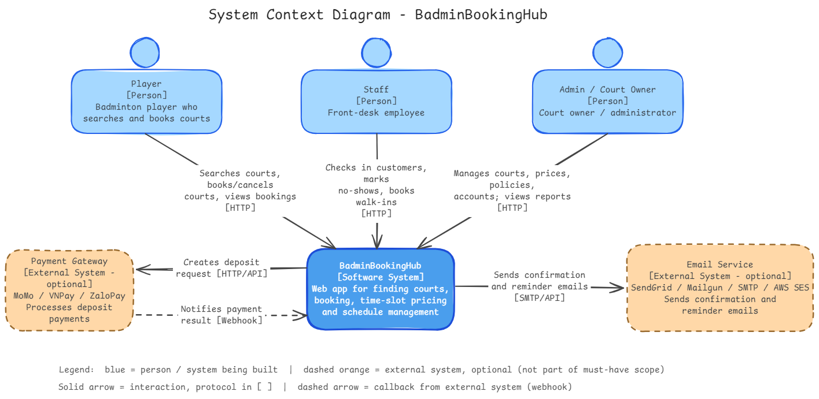

Technology Stack
Layer | Technology | Reason for choice
Front end | React, Vite, TypeScript | React supports reusable UI components for features such as court listings, availability calendars, booking forms, and administrative dashboards. Vite provides a fast development environment and production build process. TypeScript improves type safety and maintainability, especially when handling booking information, user roles, and API responses.
Back end | Node.js, Express.js, TypeScript | Express.js provides a lightweight framework for building REST APIs, Suitable for the business the team needs to implement, without requiring a framework with excessive layers of abstraction. TypeScript improves consistency and type safety across the frontend and backend.
Database | PostgreSQL | PostgreSQL is selected as the relational database for managing users, courts, operating hours, pricing rules, and bookings. Its transaction support, foreign key constraints, and data integrity mechanisms fit the application's requirements for consistent booking operations
Hosting / deployment | Docker, Docker Compose, AWS EC2, AWS ECR, AWS Systems Manager, NGINX, Certbot | Docker packages the application and its dependencies into consistent containers. Docker Compose simplifies running multiple services together. AWS EC2 hosts the deployed application. Amazon ECR stores Docker images. AWS Systems Manager provides secure instance management without requiring direct SSH access. NGINX delivers high-performance web serving and efficient reverse proxying. Certbot automates Let's Encrypt SSL certificates for secure HTTPS deployment.
Testing & CI | Vitest, React Testing Library, Supertest, Playwright, ESLint, Github Actions | Vitest supports unit testing for TypeScript code. React Testing Library tests frontend components and user interactions. Supertest tests backend API endpoints. Playwright supports end-to-end tests of complete booking workflows. ESLint detects common code-quality issues. GitHub Actions automates testing, building, and deployment whenever changes are pushed to the repository.

Hardware and Operating Environment
Development Environment: Each developer requires a laptop or desktop computer capable of running the development tools and application locally. Developers use this environment to implement features, run the application locally, and perform preliminary tests before pushing code to GitHub.
- Processor: A modern dual-core or quad-core CPU.
- Memory: At least 8 GB RAM; 16 GB is recommended when running multiple Docker containers.
- Storage: At least 20 GB of available disk space for source code, dependencies, Docker images, and local database files.
- Operating system: Ubuntu Linux, Windows with WSL2, or macOS.
- Software requirements: Node.js, npm, Docker, Docker Compose, Git, and a modern web browser.
Testing Environment: Automated tests will run on GitHub-hosted standard Ubuntu runners. GitHub Actions will install the required dependencies, run ESLint and TypeScript checks, execute automated tests, and build the Docker images. A PostgreSQL service or a Docker Compose environment will be started when database integration tests are required.
Production Environment: The application will initially be deployed to a single Amazon EC2 instance using the following configuration:
- AMI: Official Ubuntu Server 24.04 LTS, 64-bit x86 architecture.
- Instance type: t3.medium, providing 2 vCPUs and 4 GiB of memory.
- Storage: An initial 20–30 GiB EBS gp3 volume, with capacity adjusted according to application and database storage requirements.
- Container runtime: Docker Engine and Docker Compose.
- Web server: NGINX and Certbot
- Application services: Separate containers for the React frontend, Express.js backend, and PostgreSQL database.
This configuration is intended for a small demonstration deployment with low traffic. The final resource allocation will be evaluated based on observed resource consumption and application performance.

Project Plan

Process and Phase Gates
The project follows the waterfall model. Each phase ends with a phase gate (a PA submission). After a PA is submitted it becomes a baseline; later changes must be updated in the document and listed in the next PA.
PA | Phase | Due | Exit criteria (fill in)
PA1 | Initiation & planning | End of week 3 (21/10/2026) | Problem statement, product position statement, stakeholders; features prioritised with MoSCoW and out-of-scope listed (1.1). C4 context diagram, technology stack with reasons, operating environment (1.2). WBS with 3 levels, PERT estimate for every work package, Gantt with dependencies, milestones and critical path, roles with backups, cost estimate (1.3). ≥ 5 risks with RE, mitigation and owner (1.4). Protected main branch, every work package on the board with owner and due date, Discord channel with the TA (1.5). Reviewed by all members; contribution table and AI usage log complete; PDF + source on Moodle and in /pa/PA1 (1.6).
PA2 | Requirements | End of week 5  (4/11/2026) | All FRs numbered, grouped and prioritised; every NFR measurable; business rules listed; Given/When/Then acceptance criteria for Must-have features (2.2). Use case diagram and ≥ 6 Must-have use case specifications (2.3). Mockups for all Must-have use cases (2.4). Traceability matrix FR → UC → screen; requirements review held and all issues resolved (2.5). Contribution table and AI usage log complete; PDF + source on Moodle and in /pa/PA2; Git tag pa2-baseline (2.6).
PA3 | Design | End of week 7 (18/11/2026) | Architecture style justified; C4 context and container, component and deployment diagrams; ≥ 3 ADRs (3.1). Consistent class, sequence (3–5 use cases) and state diagrams with class specifications (3.2). ERD in 3NF with table specifications and indexes (3.3). Screen flow and key screen specifications (3.4). Traceability extended to design; changes since PA2 listed (3.5). Design review passed; contribution table and AI usage log complete; PDF + source on Moodle and in /pa/PA3; Git tag pa3-baseline (3.6).
PA4 | Test planning | End of week 8 (25/11/2026) | Test plan approved: scope, levels, environment, entry/exit criteria, defect management (4.1). EP, BVA and decision tables for booking rules and pricing; 15–20 test case specifications (4.2). 100% of Must-have FRs covered by at least one test case (4.3). Contribution table and AI usage log complete; PDF + source on Moodle and in /pa/PA4; Git tag pa4-baseline (4.4).
PA5 | Implementation, testing & deployment | End of week 10 (9/12/2026) | Repository scaffold and CI green on pull requests (5.1). All Must-have features Done – merged, reviewed, tested (5.2). 100% of Must-have test cases executed, ≥ 90% passed, no open critical/high defects; unit-test coverage ≥ 70% statements in the service layer; ≥ 2 use cases × 2 scenarios automated (5.3). Deployed at a public URL; video ≤ 10 minutes (5.4). Implementation report and retrospective written (5.5). Contribution table and AI usage log complete; PDF + source on Moodle and in /pa/PA5 (5.6).
Final | Presentation & demo | Week 11 (10-16/12/2026) | 15–20 slides (6.1). Every member speaks ≥ 2 minutes; booking scenario demonstrated live after two rehearsals; backup recording available (6.2).

Work Breakdown Structure (WBS)
The WBS has three levels. Level 1 is the phase: 1–5 are PA1–PA5, 6 is the final presentation and 7 is the continuous project-management work. Level 2 is a deliverable of the phase (normally a chapter of the PA document). Level 3 is the work package: every work package is at level 3, has one owner, an effort estimate (§4.3) and is one issue on the GitHub Projects board whose title starts with its WBS number (e.g., “1.3.3 Estimation”) and which is linked to the PA milestone. The WBS has 7 phases, 33 deliverables and 74 work packages; Figure below shows levels 1–2 and §4.3 lists all level-3 work packages.
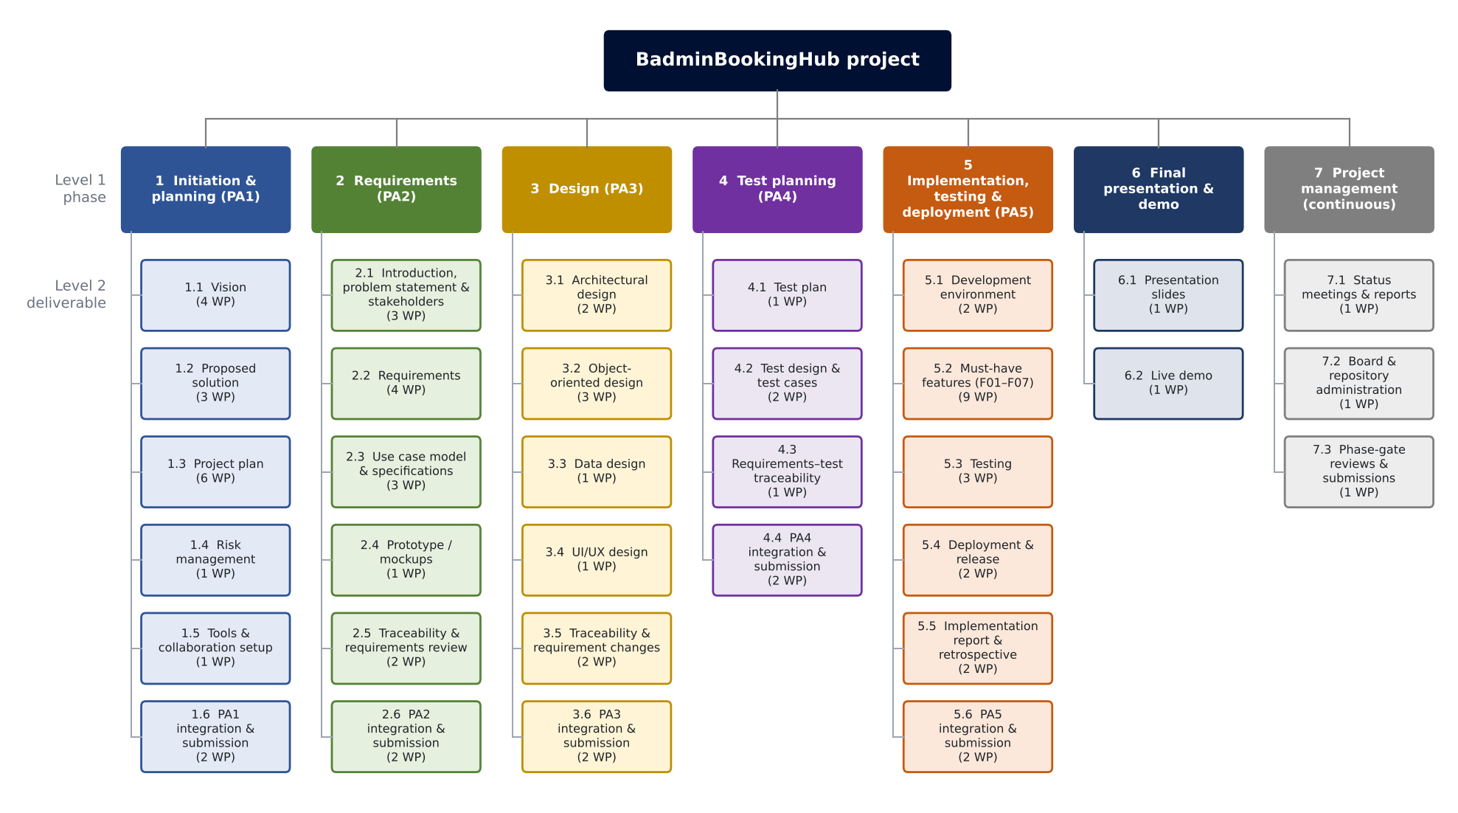
Figure - Work Breakdown Structure (levels 1-2)

Estimation
Method – three-point (PERT) estimation. For every work package the owner gave three estimates of the effort, in person-hours (hours of work by one person, not calendar time):
Symbol | Meaning | How the owner chose it
O – Optimistic | Effort if everything goes well: no rework, no blocking questions | Best case from the team's earlier course assignments of similar size
M – Most likely | Effort under normal conditions | Expert judgement of the owner: the value they would bet on
P – Pessimistic | Effort if typical problems happen: a review asks for major rework, a library has to be learnt, a member is ill for a day | Worst realistic case, not a disaster scenario
E – Expected | Value used in the plan: E = (O + 4M + P) / 6 | Weights the most likely value four times; the long tail of P pulls E slightly above M

Assumptions. Effort includes drafting, one round of peer review and corrections; learning time for new libraries is included in the implementation work packages; meetings other than the weekly status meeting are not counted separately.

WBS ID | Work package | Owner | Effort (person-hours) | Method / assumptions
1 | Initiation & planning (PA1) |  | 39.4 | Subtotal, level 1
1.1 | Vision |  | 8.6
1.1.1 | Preliminary Problem Statement | Huỳnh Mạnh Tú | 4.2 | O = 3, M = 4, P = 6
1.1.2 | Product Position Statement | Huỳnh Mạnh Tú | 1.0 | O = 0.5, M = 1, P = 1.5
1.1.3 | Stakeholders and Users | Huỳnh Mạnh Tú | 1.2 | O = 1, M = 1, P = 2
1.1.4 | Scope and Key Features (MoSCoW, out of scope) | Lê Trọng Hiếu | 2.2 | O = 1.5, M = 2, P = 4
1.2 | Proposed solution |  | 4.7
1.2.1 | Preliminary Architecture (C4 Context) | Trần Duy Khang | 2.2 | O = 1.5, M = 2, P = 4
1.2.2 | Technology Stack | Nguyễn Đại Phúc | 1.5 | O = 1, M = 1.5, P = 2
1.2.3 | Hardware and Operating Environment | Nguyễn Đại Phúc | 1.0 | O = 0.5, M = 1, P = 1.5
1.3 | Project plan |  | 13.1
1.3.1 | Process and Phase Gates | Lê Trọng Hiếu | 1.5 | O = 1, M = 1.5, P = 2
1.3.2 | WBS | Lê Trọng Hiếu | 3.2 | O = 2, M = 3, P = 5  Includes WBS diagram
1.3.3 | Estimation | Lê Trọng Hiếu | 3.0 | O = 2, M = 3, P = 4
1.3.4 | Schedule | Trần Duy Khang | 3.2 | O = 2, M = 3, P = 5  Gantt + critical path; re-drawn if estimates change
1.3.5 | Roles and Responsibilities | Phan Phú Trọng | 1.0 | O = 0.5, M = 1, P = 1.5
1.3.6 | Human Resources and Cost Estimate | Phan Phú Trọng | 1.2 | O = 1, M = 1, P = 2
1.4 | Risk management |  | 3.0
1.4.1 | Risk register | Phan Phú Trọng | 3.0 | O = 2, M = 3, P = 4
1.5 | Tools & collaboration setup |  | 3.2
1.5.1 | Repository, task board & Discord setup | Lê Trọng Hiếu | 3.2 | O = 2, M = 3, P = 5  Branch protection, board fields, PR template
1.6 | PA1 integration & submission |  | 6.8
1.6.1 | AI Usage Log (each member writes own entries) | Huỳnh Mạnh Tú | 2.6 | O = 1.5, M = 2.5, P = 4  Total for 5 members (~0.5 h each)
1.6.2 | Member Contribution, integration & submission | Lê Trọng Hiếu | 4.2 | O = 3, M = 4, P = 6  Integration, review meeting, PDF export
2 | Requirements (PA2) |  | 56.2 | Subtotal, level 1
2.1 | Introduction, problem statement & stakeholders |  | 4.6
2.1.1 | Introduction: purpose, scope & glossary | Nguyễn Đại Phúc | 1.5 | O = 1, M = 1.5, P = 2
2.1.2 | Problem Statement (elaborated from PA1) | Nguyễn Đại Phúc | 1.6 | O = 1, M = 1.5, P = 2.5
2.1.3 | Stakeholders | Huỳnh Mạnh Tú | 1.5 | O = 1, M = 1.5, P = 2
2.2 | Requirements |  | 13.1
2.2.1 | Functional Requirements | Huỳnh Mạnh Tú | 5.3 | O = 4, M = 5, P = 8  25–30 FRs for 7 Must + 3 Should features
2.2.2 | Non-Functional Requirements | Nguyễn Đại Phúc | 2.1 | O = 1.5, M = 2, P = 3
2.2.3 | Domain Requirements and Business Rules | Lê Trọng Hiếu | 1.5 | O = 1, M = 1.5, P = 2
2.2.4 | Acceptance Criteria (Given/When/Then) | Phan Phú Trọng | 4.2 | O = 3, M = 4, P = 6
2.3 | Use case model & specifications |  | 19.7
2.3.1 | Use Case Model: diagram, actors, use case list | Huỳnh Mạnh Tú | 4.2 | O = 3, M = 4, P = 6
2.3.2 | Use case specifications: booking, cancellation, calendar, rules | Huỳnh Mạnh Tú | 8.3 | O = 6, M = 8, P = 12  1.5–2 h per use case incl. alternative flows
2.3.3 | Use case specifications: auth, court management, front desk | Phan Phú Trọng | 7.2 | O = 5, M = 7, P = 10  1.5–2 h per use case
2.4 | Prototype / mockups |  | 10.5
2.4.1 | Prototype / Mockups (Figma) | Trần Duy Khang | 10.5 | O = 8, M = 10, P = 15  Figma; 10 screens; P covers a redesign after review
2.5 | Traceability & requirements review |  | 4.2
2.5.1 | Requirements Traceability Matrix | Lê Trọng Hiếu | 2.1 | O = 1.5, M = 2, P = 3
2.5.2 | Requirements Review | Phan Phú Trọng | 2.1 | O = 1.5, M = 2, P = 3
2.6 | PA2 integration & submission |  | 4.1
2.6.1 | AI Usage Log (each member writes own entries) | Huỳnh Mạnh Tú | 2.6 | O = 1.5, M = 2.5, P = 4  Total for 5 members (0.5 h each)
2.6.2 | Member Contribution, integration & submission | Lê Trọng Hiếu | 1.5 | O = 1, M = 1.5, P = 2
3 | Design (PA3) |  | 48.1 | Subtotal, level 1
3.1 | Architectural design |  | 9.8
3.1.1 | Design Overview: goals and constraints | Trần Duy Khang | 1.5 | O = 1, M = 1.5, P = 2
3.1.2 | Architectural Design: style, C4 L1–L2, components, deployment, ADRs | Trần Duy Khang | 8.3 | O = 6, M = 8, P = 12  C4 L1–L2, component, deployment, 3 ADRs
3.2 | Object-oriented design |  | 16.1
3.2.1 | Domain model, class diagram & class specifications | Nguyễn Đại Phúc | 8.3 | O = 6, M = 8, P = 12  6–8 classes specified
3.2.2 | Sequence & state machine diagrams | Huỳnh Mạnh Tú | 6.3 | O = 5, M = 6, P = 9
3.2.3 | Design Principles and Patterns | Nguyễn Đại Phúc | 1.5 | O = 1, M = 1.5, P = 2
3.3 | Data design |  | 6.3
3.3.1 | Data Design: ERD, table specs, normalisation, indexes | Phan Phú Trọng | 6.3 | O = 5, M = 6, P = 9
3.4 | UI/UX design |  | 7.2
3.4.1 | UI/UX Design: screen flow, screen specs, accessibility | Trần Duy Khang | 7.2 | O = 5, M = 7, P = 10
3.5 | Traceability & requirement changes |  | 3.1
3.5.1 | Traceability Update | Lê Trọng Hiếu | 2.1 | O = 1.5, M = 2, P = 3
3.5.2 | Changes to the Requirements Since PA2 | Huỳnh Mạnh Tú | 1.0 | O = 0.5, M = 1, P = 1.5
3.6 | PA3 integration & submission |  | 5.6
3.6.1 | AI Usage Log (each member writes own entries) | Huỳnh Mạnh Tú | 2.6 | O = 1.5, M = 2.5, P = 4  Total for 5 members (0.5 h each)
3.6.2 | Member Contribution, design review & submission | Lê Trọng Hiếu | 3.0 | O = 2, M = 3, P = 4
4 | Test planning (PA4) |  | 23.4 | Subtotal, level 1
4.1 | Test plan |  | 5.3
4.1.1 | Test Plan | Phan Phú Trọng | 5.3 | O = 4, M = 5, P = 8
4.2 | Test design & test cases |  | 12.5
4.2.1 | Test Design: EP, BVA, decision tables | Huỳnh Mạnh Tú | 4.2 | O = 3, M = 4, P = 6
4.2.2 | Test Cases: list and 15–20 specifications | Phan Phú Trọng | 8.3 | O = 6, M = 8, P = 12  15–20 test cases × ~25 min
4.3 | Requirements–test traceability |  | 1.5
4.3.1 | Requirements–Test Traceability | Lê Trọng Hiếu | 1.5 | O = 1, M = 1.5, P = 2
4.4 | PA4 integration & submission |  | 4.1
4.4.1 | AI Usage Log (each member writes own entries) | Huỳnh Mạnh Tú | 2.6 | O = 1.5, M = 2.5, P = 4  Total for 5 members (~0.5 h each)
4.4.2 | Member Contribution, integration & submission | Lê Trọng Hiếu | 1.5 | O = 1, M = 1.5, P = 2
5 | Implementation, testing & deployment (PA5) |  | 139.1 | Subtotal, level 1
5.1 | Development environment |  | 9.4
5.1.1 | Source code structure: repo scaffold, Docker Compose, coding standards | Nguyễn Đại Phúc | 6.2 | O = 4, M = 6, P = 9  Includes learning Docker/Prisma
5.1.2 | Continuous Integration (GitHub Actions) | Nguyễn Đại Phúc | 3.2 | O = 2, M = 3, P = 5
5.2 | Must-have features (F01–F07) |  | 87.0
5.2.1 | F01-BE Authentication & role-based access API | Nguyễn Đại Phúc | 10.5 | O = 8, M = 10, P = 15  JWT, 3 roles, password hashing
5.2.2 | F01-FE Login/registration pages & app layout | Lê Trọng Hiếu | 6.3 | O = 5, M = 6, P = 9
5.2.3 | F02-BE Court catalog & court management API (F02, F06) | Trần Duy Khang | 10.3 | O = 8, M = 10, P = 14
5.2.4 | F03-BE Booking engine: pricing, no-overlap, cancellation | Nguyễn Đại Phúc | 16.0 | O = 12, M = 15, P = 24  P covers concurrency issues (risk R1)
5.2.5 | F04-FE Availability calendar & booking UI (F03, F04) | Trần Duy Khang | 12.7 | O = 10, M = 12, P = 18  Largest UI: real-time slot grid
5.2.6 | F05-BE Booking rules: weekly limit, advance window, cancellation deadline | Lê Trọng Hiếu | 6.3 | O = 5, M = 6, P = 9  3 rules + unit tests
5.2.7 | F06-FE Admin court management UI | Phan Phú Trọng | 8.3 | O = 6, M = 8, P = 12
5.2.8 | F07-BE Front-desk operations API | Huỳnh Mạnh Tú | 8.3 | O = 6, M = 8, P = 12
5.2.9 | F07-FE Staff front-desk UI | Huỳnh Mạnh Tú | 8.3 | O = 6, M = 8, P = 12
5.3 | Testing |  | 25.1
5.3.1 | Unit Tests and Coverage | Nguyễn Đại Phúc | 8.3 | O = 6, M = 8, P = 12
5.3.2 | Automated System Tests (Playwright, 2 UC × 2) | Phan Phú Trọng | 6.5 | O = 5, M = 6, P = 10  2 use cases × 2 scenarios
5.3.3 | Test execution, test case results & defect list | Phan Phú Trọng | 10.3 | O = 8, M = 10, P = 14
5.4 | Deployment & release |  | 8.4
5.4.1 | Deployment (AWS + Docker), release & user guide | Nguyễn Đại Phúc | 6.3 | O = 4, M = 6, P = 10  P covers cloud set-up problems (risk R8)
5.4.2 | Working Software Video | Trần Duy Khang | 2.1 | O = 1.5, M = 2, P = 3
5.5 | Implementation report & retrospective |  | 5.1
5.5.1 | Implementation report: feature status, code review, static analysis, deviations | Huỳnh Mạnh Tú | 3.0 | O = 2, M = 3, P = 4
5.5.2 | Project Retrospective | Lê Trọng Hiếu | 2.1 | O = 1.5, M = 2, P = 3
5.6 | PA5 integration & submission |  | 4.1
5.6.1 | AI Usage Log (each member writes own entries) | Huỳnh Mạnh Tú | 2.6 | O = 1.5, M = 2.5, P = 4  Total for 5 members (~0.5 h each)
5.6.2 | Member Contribution, integration & submission | Lê Trọng Hiếu | 1.5 | O = 1, M = 1.5, P = 2
6 | Final presentation & demo |  | 10.5 | Subtotal, level 1
6.1 | Presentation slides |  | 6.3
6.1.1 | Presentation slides (15–20) | Trần Duy Khang | 6.3 | O = 5, M = 6, P = 9
6.2 | Live demo |  | 4.2
6.2.1 | Demo script & rehearsal (all members) | Lê Trọng Hiếu | 4.2 | O = 3, M = 4, P = 6
7 | Project management (continuous) |  | 35.9 | Subtotal, level 1
7.1 | Status meetings & reports |  | 18.3
7.1.1 | Weekly status meetings & reports (W2–W10) | Lê Trọng Hiếu | 18.3 | O = 14, M = 18, P = 24  9 reports × 2 h
7.2 | Board & repository administration |  | 9.3
7.2.1 | Task board & repository administration | Lê Trọng Hiếu | 9.3 | O = 6, M = 9, P = 14  1 h per week, W3–W10
7.3 | Phase-gate reviews & submissions |  | 8.3
7.3.1 | Phase-gate reviews & Moodle submissions | Lê Trọng Hiếu | 8.3 | O = 6, M = 8, P = 12  Review + submission of 5 PAs
 | Total planned effort |  | 352.6 | Sum of expected values

Schedule
The schedule is derived from the effort estimates in §4.3: each work package's duration is ROUNDUP(effort ÷ daily capacity) working days, tasks are sequenced by their predecessors and by the availability of their owner, and the critical path is found with the Critical Path Method. The full schedule is maintained in Link Google Sheets: PA1-08_4.4_Schedule_Gantt
Assumptions
- Calendar: week 1 starts on Thursday 01/10/2026 and weeks run Thursday–Wednesday, so the PA deadlines of §4.1 fall on Wed 21/10, 04/11, 18/11, 25/11 and 09/12; the final presentation is in week 11 (10–16/12, date to be announced). An internal milestone is added on Mon 07/12: all Must-have features done (§2.4).
- Capacity: the team contract commits 8–10 h per week for documentation and 12–15 h per week for implementation. The plan uses the upper bound spread over all seven days: 10 ÷ 7 ≈ 1.4 h/day for documentation and 15 ÷ 7 ≈ 2.1 h/day for code. PA1 had only one week and was planned at 4 h/day.
- Effort ≠ duration: 5.2.4 F03-BE (booking engine) needs 16 h of effort, i.e. 8 days at 2.1 h/day (Thu 19/11 – Thu 26/11).
- Internal deadline: each member finishes their part on the Monday before a PA deadline, the Tuesday meeting is used for review and the PM submits on Wednesday (team contract §3.5). Slack is measured against that Monday.
- Level-of-effort work (project management 7.x, AI usage logs x.6.1) and the review/submission packages (x.6.2, 2.5.2) have fixed dates and are not part of the critical path.
Fitting the phase gates
The gates are only one or two weeks apart, so starting each phase after the previous gate does not fit. The schedule therefore uses:
- Fast-tracking: functional requirements (2.2.1) and mockups (2.4.1) start in week 3, PA3 design in week 5, the repository scaffold and CI (5.1.1, 5.1.2) in week 6 and the first back-end features (5.2.1, 5.2.3) in week 7.
- V-model: test design (4.2.1) starts on 03/11 and the test plan (4.1.1) on 08/11, in parallel with PA3.
With these measures every work package keeps the owner given in §4.3 and no work package has negative slack.
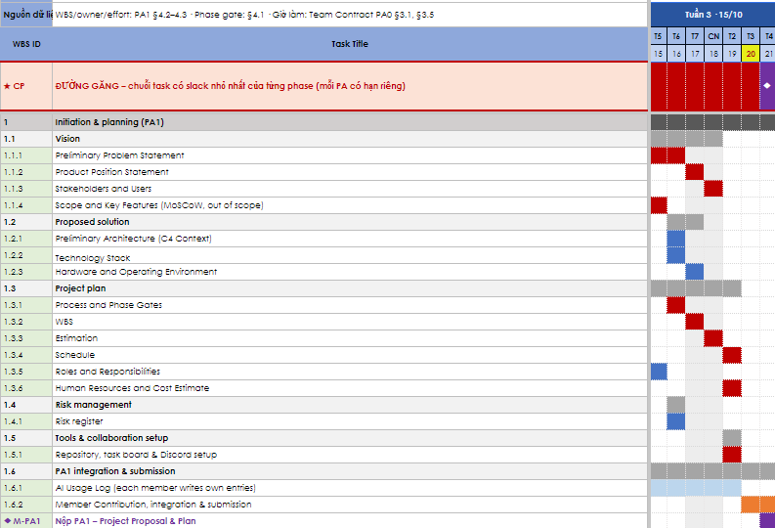
Figure 1 – Gantt chart, PA1 - week 3
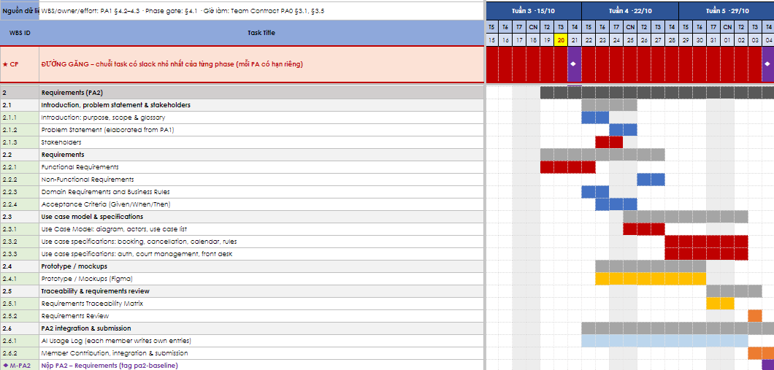

Figure 2 – Gantt chart, PA2 - weeks 3, 4, 5
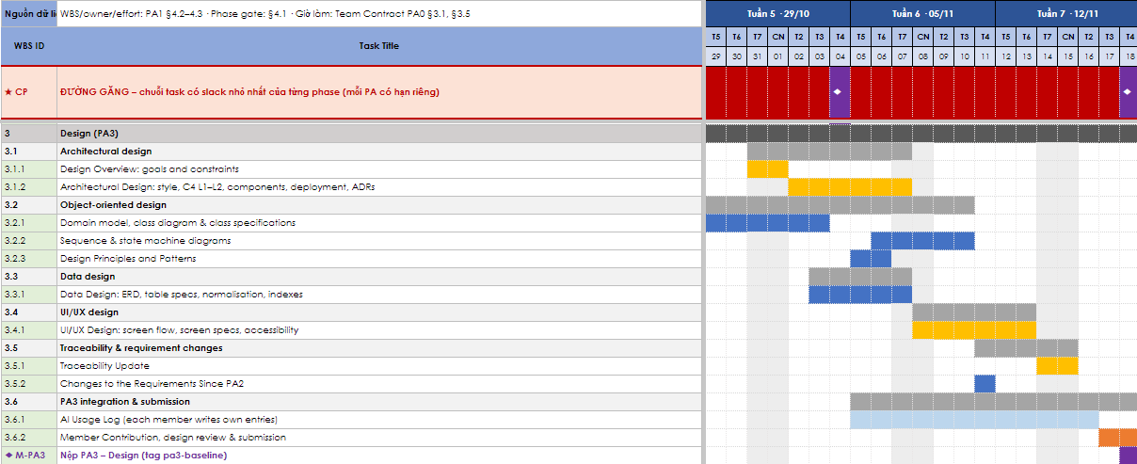
Figure 3 – Gantt chart, PA3 - weeks 5, 6, 7
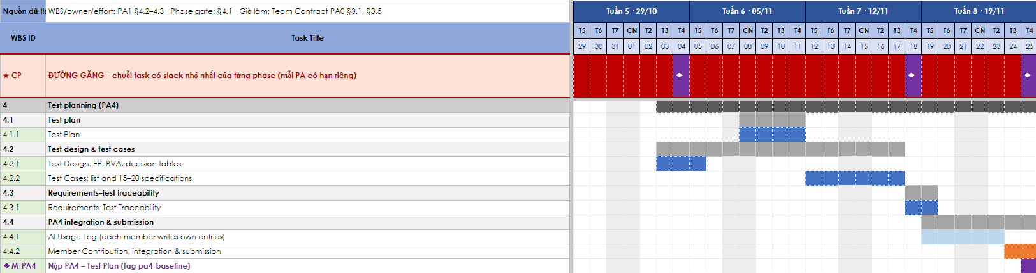
Figure 4 – Gantt chart, PA4 - weeks 5, 6, 7, 8
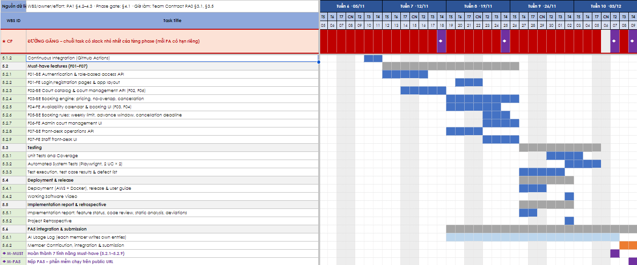
Figure 5 – Gantt chart, PA5 - weeks 6, 7, 8, 9, 10
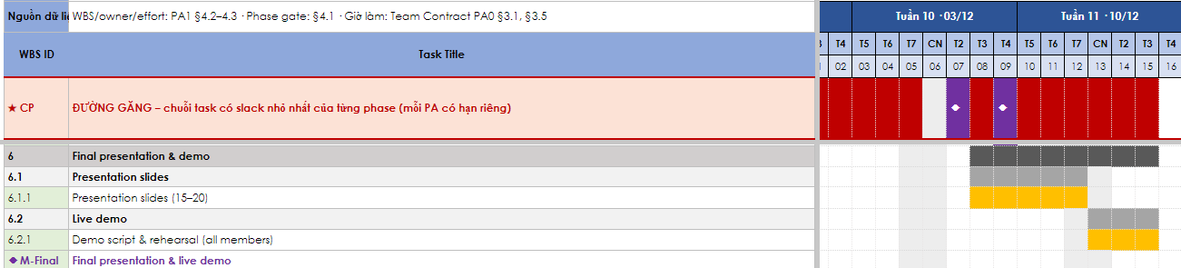
Figure 6 – Gantt chart, Final - weeks 10, 11
Highlight color legend:
- Red: critical (slack 0).
- Amber: near-critical (slack 1).
- Blue: other tasks.
- Light blue: level of effort.
- Orange: review & submission.
- Purple: milestones .
Critical path. Because every PA has its own fixed deadline, the critical path is determined per phase as the chain of work packages with the smallest slack:
Phase | Critical path (work packages in order, owner) | Slack (days)
PA1 | 1.1.4 → 1.3.1 → 1.3.2 → 1.3.3 (Hiếu) → 1.3.4 (Khang) | 0
PA2 | 1.1.1 → 1.1.2 → 1.1.3 → 2.2.1 → 2.1.3 → 2.3.1 → 2.3.2 (all Tú) | 0
PA3 | 2.4.1 → 3.1.1 → 3.1.2 → 3.4.1 (Khang) → 3.5.1 (Hiếu) | 1
PA4 | 3.3.1 → 4.1.1 → 4.2.2 (Trọng) → 4.3.1 (Hiếu) | 2
PA5 | 5.2.3 (Khang) → 5.2.4 (Phúc) → 5.3.3 → 5.3.2 (Trọng) → ◆ Must-have Mon 07/12 | 2
Final | 6.1.1 (Khang) → 6.2.1 (Hiếu) → ◆ Final presentation (week 11) | 1

The tightest chain is the requirements work of the business analyst (Tú): it starts in PA1 and runs without slack to the PA2 internal deadline on Mon 02/11. §4.3 contains no management reserve and weekends are already scheduled, so slack is the only buffer – one day of slack is only about 1.4–2.1 h of work. Critical and near-critical work packages (slack ≤ 1) are reviewed in every Tuesday meeting; if one slips, the owner adds hours or Should-have features are dropped (§2.4), see the risk register in §5.

Roles and Responsibilities
Role | Main | Backup | Responsibilities
Team lead / Project manager | Lê Trọng Hiếu | Trần Duy Khang | Plan, assign tasks, weekly status report, contact point
Business analyst | Huỳnh Mạnh Tú | Lê Trọng Hiếu | Elicit and document requirements, organise reviews
Designer / Architect | Trần Duy Khang | Huỳnh Mạnh Tú | Architecture, class, data and UI design
Developers | Nguyễn Đại Phúc | Phan Phú Trọng | Implement, unit test, review pull requests
Tester | Phan Phú Trọng | Nguyễn Đại Phúc | Test plan, test cases, system testing, test report

Human Resources and Cost Estimate

Human resources and effort
Member | Role | Main responsibilities | Hours | Cost (VND)
Lê Trọng Hiếu | Project manager / Frontend developer | Planning, WBS, status meetings, repo and board admin, phase-gate submissions, login UI, booking rules | 86.8 | 6,076,000
Huỳnh Mạnh Tú | Business analyst / Full-stack developer | Vision, stakeholders, functional requirements, use cases, sequence diagrams, front-desk API and UI | 69.8 | 4,886,000
Nguyễn Đại Phúc | Tech lead / Backend and DevOps developer | Technology stack, domain model, Docker and CI, authentication API, booking engine, unit tests, AWS deployment | 68.0 | 4,760,000
Trần Duy Khang | UI/UX designer / Architect / Frontend developer | C4 architecture, Figma mockups, UI/UX design, court catalog API, availability calendar and booking UI, demo video, slides | 64.3 | 4,501,000
Phan Phú Trọng | QA / Data designer / Developer | Risk register, acceptance criteria, ERD, test plan and test cases, Playwright tests, test execution, admin court UI | 63.7 | 4,459,000
Total |  |  | 352.6 | 24,682,000
Labor cost: 352.6 h × 70,000 VND/h = 24,682,000 VND

Tools, hosting and other costs
Item | Basis | Cost (VND)
AWS EC2 (t3.medium) running Docker Compose | AWS Free Tier | 0
EBS storage (20 GB gp3) | AWS Free Tier | 0
Public IPv4 / Elastic IP | AWS Free Tier | 0
AWS ECR (Docker images under 1 GB) | AWS Free Tier | 0
AWS Systems Manager (access without SSH) | free | 0
PostgreSQL management fee (self-hosted in a Docker container, no RDS) | none required | 0
SSL certificate (Certbot / Let’s Encrypt) | free | 0
GitHub, GitHub Actions, Figma (education), Discord, Moodle | free / student plans | 0
Open-source tools (Vitest, React Testing Library, Supertest, Playwright, ESLint) | free | 0
Miscellaneous (printing, demo materials) | one-time | 300,000
Subtotal (non-labor) |  | 300,000

Total cost summary
Category | Cost (VND)
Labor (352.6 h × 70,000 VND/h) | 24,682,000
Tools, hosting and other costs | 300,000
Estimated total | 24,982,000

Risk Management
Risk exposure RE = Probability × Loss
ID | Risk | Type | Probability | Loss | RE | Mitigation / contingency | Owner
R1 | Integration errors between the React frontend and the Node.js/Express backend: the two sides are built in parallel, API contracts change, and late integration exposes bugs in request/response formats, authentication, and data stored in PostgreSQL. The web app must also work on both desktop and mobile browsers. | Technology | Likely (75) | Serious (75) | 5625 | Define the REST API contract and use mock endpoints so the React frontend can be built before the backend is ready. Use versioned database migrations and shared seed data for PostgreSQL. Test the API with Postman collections and integration tests, and deploy to a shared staging server. Check responsive layouts on desktop and mobile browsers at each milestone. Contingency: schedule a dedicated integration week and fix the highest-priority endpoints first. | Developer
R2 | Junior developers lack experience with the chosen framework and with good practices (code structure, version control, code review), leading to rework, technical debt and bugs. A key developer may also leave mid-project. | People | Likely (75) | Moderate (50) | 3750 | Provide a short training period, enforce pull requests with mandatory code review, use pair programming. Keep documentation current so tasks can be handed over. Contingency: reassign tasks within the team or ask TA. | Project manager
R3 | Poor team coordination and unclear responsibilities between waterfall phases: handovers from requirements to design, development and testing are incomplete or late, so team members wait for each other’s deliverables, work is duplicated, and delays in one phase push back all later phases. | Organisational | Occasional (50) | Serious (75) | 3750 | Define a clear deliverable, owner and deadline for each phase in the project plan (Gantt chart). Hold a weekly team meeting to review progress against the plan, and use a formal sign-off or review at the end of each phase before the next one starts. Contingency: re-plan the schedule, overlap phases where possible, and rebalance the workload. | Project manager
R4 | Requirements are vague or change during development causing scope creep and rework of design, code and tests. | Requirements | Frequently (90) | Moderate (50) | 4500 | Freeze the MVP scope in a signed requirements document with clear acceptance criteria. Handle new ideas through a change-request process and a “phase 2” backlog. Contingency: drop low-priority features to protect the deadline. | Business analyst
R5 | The 352.6-hour estimate is too low and testing is squeezed: junior developers work slower than planned, bug fixing and QA are underestimated, and testing is left to the end, so defects are found late. | Estimation | Likely (75) | Serious (75) | 5625 | Test continuously: unit tests and QA in every sprint instead of only at the end. Add a QA buffer on top of the contingency, track actual vs estimated hours weekly, and re-estimate after each sprint. Contingency: use the contingency budget and reduce scope to the core MVP. | Project manager

Tools & Collaboration Setup
One of the main goals of the project is to practise teamwork for professional software development. The use of tools is monitored and graded (teamwork component). The team must use:
- Moodle – announcements and PA submissions.
- Communication – Slack, MS Teams or Discord: one channel per team; the TA is a member.
- Task board – GitHub Projects (recommended) or Jira: every WBS work package is a task with an owner and due date.
- Git repository – GitHub (recommended), GitLab or Bitbucket; the instructor and TA have access:
  - main branch is protected; changes are merged through pull requests with at least one review
  - README (description, setup), .gitignore; never commit secrets (.env, API keys, passwords)
  - commit messages follow the Conventional Commits style (feat:, fix:, docs:, test:, …)
- Weekly status meeting (15 minutes) and weekly status report (template provided), committed to /docs/management/weekly every week from week 2 to week 10. The team chooses its weekly deadline and states it here.

Repository structure:
Folder | Content
/src | Source code
/docs/management | Project plan; weekly status reports in /docs/management/weekly
/docs/requirements | Vision, SRS, use cases, mockups
/docs/design | Architecture (C4), ADRs, UML models, UI design
/docs/test | Test plan, test cases, test reports
/docs/ai-usage | AI usage logs
/pa/PA1 … /pa/PA5 | One sub-folder per PA submission (PDF + source files)

AI Usage Log
# | Member | Tool | Task / purpose | How the output was verified and changed
1 | 24127577 | ChatGPT | Discussed and refined the preliminary problem statement in PA1 | Compared the suggestions with PA0, clarified the current problems and proposed solution, and revised the wording to match the project's scope and constraints
1 | 24127577 | ChatGPT | Developed the product position statement for BadminBookingHub | Checked the target customers, user needs, product benefits, current alternatives, and differentiation against PA0; selected and refined the final wording
2 | 24127168 | Claude | Review of PA1 §4 Project Plan: exit criteria (4.1), 3-level WBS renumbering (4.2), check of PERT estimates (4.3) | PERT values and totals recomputed; schedule checked against PA deadlines and team-contract hours; scheduling decisions (week-7 set-up, early deployment, levelling) discussed with the team before adoption; text rewritten into our own words in the PA1 document
3 | 24127183 | Claude | Provide guidance on creating the C4 System Context Diagram (Section 3.1) and completing the diagram. | Verified the AI-generated diagram against PA0 requirements and project scope.  Adjusted entities, relationships, and labels to match the actual system context.
3 | 24127183 | Gemini | Summarize the requirements and implementation guidelines for Sections 3.1 and 4.4.  Clarify the dependency relationships between Section 4.4 and Sections 4.1–4.3. | Verified the AI suggestions against the PA requirements and team discussions.  Confirmed the dependencies between Sections 4.1, 4.2, 4.3, and 4.4 before applying them to the Gantt Chart.  Reviewed and adjusted milestones, WBS structure, effort estimates, and critical path information to match the team's final plan.
4 | 23127134 | Claude | Asked about frequently happening problems in software engineer projects,... | Pick 5 problem and assign value and solution to them
5 | 24127500 | ChatGPT | Researched and compared technology stack options, CI/CD infrastructure, and hardware requirements for Sections 3.2 and 3.3. | valuated the suggestions against project requirements, compared alternative technologies, and refined the final choices based on experience, feasibility, development time, and deployment costs.

